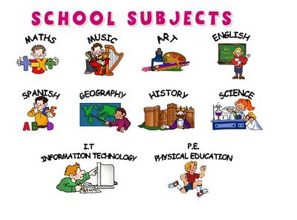  Dr Xargles Book of Earthlets by Jeanne Willis. Our topic question is ‘What makes humans special?’  Amazing Grace by Mary Hoffman. Our topic question is ‘Can we be anything we want?’ | Fractions  Recognising fractions such as 1/2, 1/4, ¾, 1/3. Finding 1/2 , 1/4 , ¾ and 1/3 of shapes and numbers.  Time  Learning to tell the time. Knowing o’clock, half past, quarter past, quarter to. Telling the time to 5 minutes. | Painting Landscapes  Express a clear preference when looking at creative work and give reasons.  Confidently control marks using a range of mixed media. (Derby landscape)  Describe the similarities between different practices and make links to my own work (comparing landscapes by O’keeffe and J. Wright) | Animals, including humans  Classify foods in a range of ways.  Investigate the effect of exercise on bodies.  Use pictures, charts, or tables to record my observations.  Measure and observe how animals including humans grow.
  Balloon powered car project.  Use hand tools safely.  Measure with some accuracy.  Use a range of tools and equipment to perform practical tasks.  Computing  Getting set up on and exploring purple mash! Creating their own avatar. | Year 2– Summer 1  2023  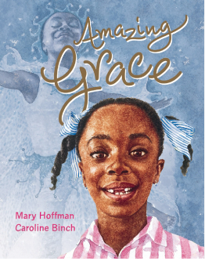  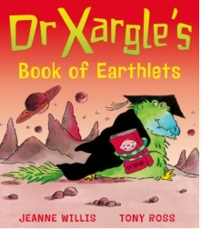 |  |   R.E  Exploring and discussing what happens during Eid.
Recognise visual symbols and stick notation.
Sing and respond to visual symbols.
Striking and fielding  Begin to self-manage a small sided game, learn how to score points and play to the rules. Learn skills, strategies and tactics to outwit the opposition.  Ball skills  Throwing and catching, rolling, hitting a target, dribbling with both hands and feet and kicking a ball. | Plot the capital cities of England, Wales, Scotland and Ireland.  Describe geographical similarities and differences of the UK and a contrasting non-European country. | No History this half term | 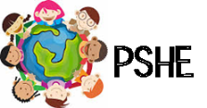  Relationships  Learning about friendships and how to manage conflict. Thinking about how to stay safe - exploring physical contact.  Talking about our families and the relationship that we have with them. Learning how to show respect for others and discussing trust and appreciation.

