Have a chocolate tasting afternoon!  Milk/White/Dark/ With added ingredients eg popping candy etc.  Discuss your favourite chocolate, why?  Use adjectives to talk about the different chocolates e.g. bitter/sweet/creamy/crunchy  Have fun! | Design chocolate bar  Using your knowledge of chocolate design a chocolate bar that would be your new favourite!  Is it white chocolate? Does it have a mix of two chocolates? Are there raisins in it? Etc.  Draw this in your book and label it! | Design a wrapper  Look at different chocolate wrappers and think about what you think makes a good wrapper.  Think about your chocolate bar and design your own! Remember to think about the colour/ the name of your chocolate bar/ any pictures on the front. 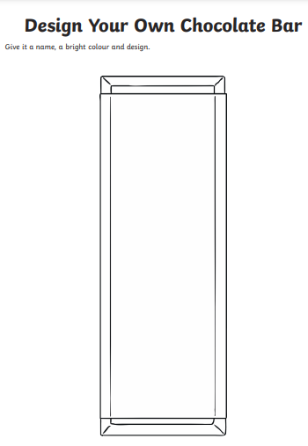 | Evaluate your chocolate bar  If you can get the ingredients in your essential shop have a go at making your chocolate bar. Try it and think about if it was as good as you thought it would be! Does your wrapper suit your chocolate? If not – why? What could you change?  If you cannot get the ingredients no problem! Ask everyone in your house if they think they would like your chocolate bar/Wrapper? If not –why? What could you change?
Make a rainforest in a shoe box  As we know – Cocoa beans (What we make chocolate from) are grown in the rainforest!  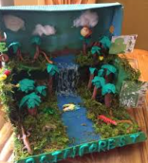  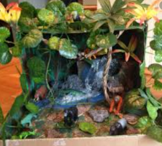  I want to challenge you to create a rainforest in a shoe box! | 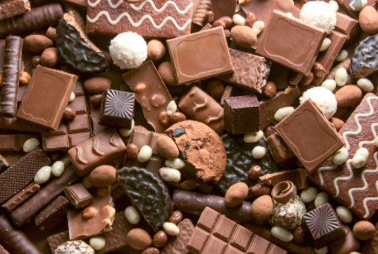  ART & DESIGN |  | Aztec art  History shows that Aztecs loved chocolate so much that they thought it was a gift from the gods and it was more precious than gold!  They also believed that there were 4 suns before our sun and made beautiful pieces of art called ‘Aztec sun’s’  Try and draw and colour your own Aztec sun! 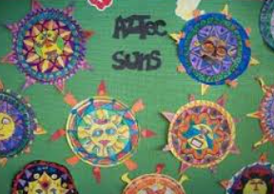 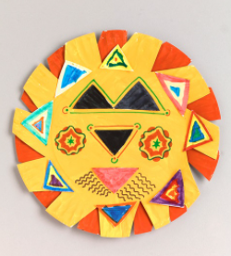
Design an Easter egg  With Easter approaching why not try and design a chocolate Easter egg! | Chocolate Pollock painting  Have a go at making a piece of art based on Jackson Pollock’s drip art! You will need some chocolate to try this art out!  https://www.tate.org.uk/kids/make/paint-draw/make-chocolate-painting |  | Draw a chocolate bar -Follow this link for instructions for how to draw a chocolate bar!  https://www.youtube.com/watch?app=desktop&v=O_c4I5vnlkw

