FIRST ACTIVITY  Please watch Michael Rosen perform his poem Chocolate Cake  https://www.youtube.com/watch?v=7BxQLITdOOc  Then please ask your children the following questions to write in their books.  -What is the poem about?  -When did he go and get some chocolate cake?  -What happened to the chocolate cake?  -How did his mum know it was him? | Tongue Twisters  Michael Rosen’s Chocolate Cake is full of playful phrases and interesting words.  Tongue twisters are a great way to warm up for drama and are also very effective when encouraging children to feel more confident with language.  Here is are some tongue twisters to try:  The big beautiful blue balloon burst.  Cooks cook cupcakes quickly.  Betty bought butter but the butter was bitter, so Betty bought better butter to make the bitter butter better. | Drama Exercise  Favourite Foods  Using the script on the website help your child to act out eating their favourite food. Encourage them to use facial expression as well as physical movements. | Wordsearch  Find all the words in the wordsearch. Once you’ve found them can you use each word in your own sentence?  Wordsearch is available on the school website.  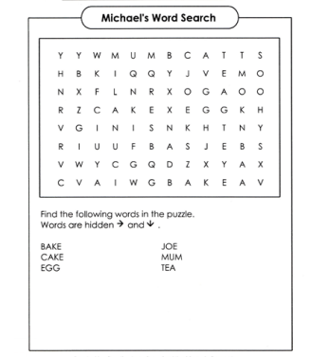
Perform your own poem  Choose from the 3 poems on the website, practice performing them and send in a video of your performance to Dojo.  Remember to use your facial expression and make the words sounds really interesting, like Michael Rosen does.  Extra Challenge – can you learn your poem off by heart? | 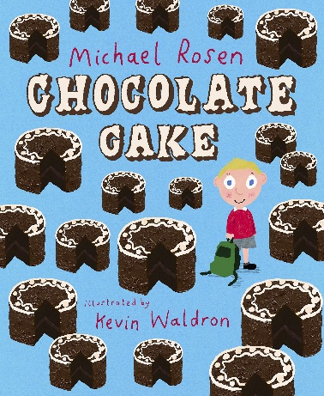 |  | Scrumptious Sentences  Using the sheet complete this scrumptious sentence using the word bank on the page  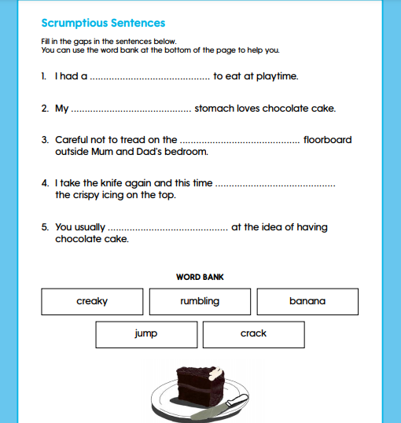
Syllables  Visit: Counting syllables - Year 1 - P2 - English - Catch Up Lessons - Home Learning with BBC Bitesize - BBC Bitesize and watch the video.  How many syllables are in the word chocolate? Clap the word out to help work it. Have a go at the syllable worksheet on the website. | Rhyming  Visit What are rhyming words? - BBC Bitesize and watch the video.  Then have a go at the rhyming sheet on the website  Extra Challenge: choose some objects from around your house- can you think of words that rhyme with them? | Write your own poem,  Watch How to write a poem - BBC Bitesize to find out how to write a poem and the have a go at writing a poem about your favourite food. | FINAL ACTIVITY  Write a list of 3 of your favourite chocolate flavoured items. Then head out for your daily walk to the shop and buy what it is on your list. Ask you parents to help you to buy what’s on your list.  Head back home and snuggle up on the sofa with you chocolate treats and watch a film. ENJOY.

