Day 1  Watch this video on ‘The History of Chocolate’ and see if you can answer these questions:  History of Chocolate For Kids - YouTube  1. Who first discovered chocolate? (the Olmecs/Mayans)  2. What fruit/bean is chocolate made from? (the Cacao fruit/bean)  3. How did the Aztecs first use chocolate? (they drank it!)  4. Who made the first chocolate bar ever? (Fry’s)  5. What is your favourite chocolate? | Day 2  Using the ‘Mayan hot chocolate recipe’, have a go at making Mayan hot chocolate!  When you have tried your Mayan hot chocolate, answer these questions:  1. What did it taste of?  2. Can you describe the hot chocolate in 3 words?  3. Do you prefer Mayan hot chocolate or the hot chocolate we have today? Why?  Post pictures of your hot chocolate on dojo! |  | Day 3  Read through ‘The History of Chocolate timeline’.  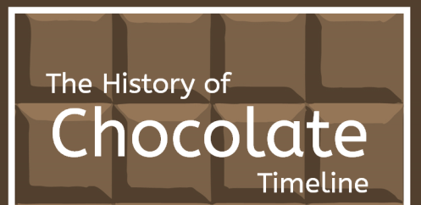  Then use the History of Chocolate timeline activity to match the events of discovering chocolate to the dates that they happened! |  | Day 4  The Aztecs created masks – to display as ornaments or for use in rituals. They could have held rituals celebrating chocolate!  Have a look at the ‘Aztec masks’ page. Your task is to create your own Aztec mask – use the ‘design a mask’ sheet to help you plan. Have a think about the materials and patterns you are going to use. Create your mask and let us see your creations!
Day 5  Have a read of the powerpoint ‘Where does chocolate come from?’ Complete the activities within the powerpoint and answer the questions! Using the glossary at the end of the powerpoint, talk with your grown up about what these words mean. Can you explain what all of the words mean? See if your grown up can video you talking about these words and post it to dojo! |  | The History of Chocolate  2 Week Topic plan  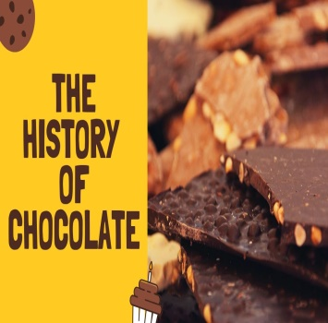 |  | Day 6  Using yesterday’s powerpoint information to help you, can you write down and explain how chocolate is made?  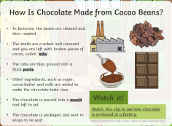  Your grown up might need to help you.
Day 7  Choose your favourite type of chocolate and see if you can discover how it is made in the factory.  Using a storyboard template, can you draw pictures in each box to describe how your favourite chocolate bar is made? | Day 8  Have a look through the ‘fair trade chocolate’ powerpoint. Watch the video of the Kuapa Kokoo farmers harvesting the beans. Complete the ordering activity within the powerpoint to show the sequence of events at harvest time.  Can you write down three facts that you have learnt? |  | Day 9  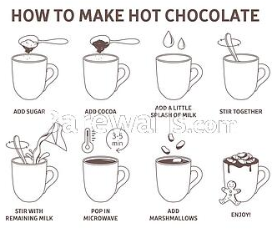  Using all of your knowledge about the history of chocolate, make a poster! You can make it about how chocolate was discovered or even how chocolate is made! |  | Day 10  Relax and enjoy watching a video of how chocolate is made with a visit to the chocolate factory!  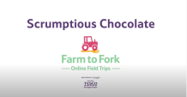  Learn how chocolate is made with a visit to the chocolate factory - YouTube

