Day 1  https://www.youtube.com/watch?v=HtK1dKp3x-o  Please watch the video of ‘The Queen’s Orangutan’  Ask your child questions about the story eg.  -Who is the author (wrote the story)?  Who is the illustrator (drew the pictures)?  -Who was your favourite character? Why?  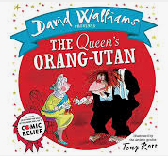 | Day 2  Can you design a new front cover for the story?  What picture would sum up the story? What characters? What are the characters doing?   | Day 3  Use your phonics to sound key words in the story eg. Queen, Ape, stuff, plop  Ask your child to write these down - help with any letter formation   | Day 4  Orally form a sentence about what you would do if you were queen for the day  Grown up to write this down  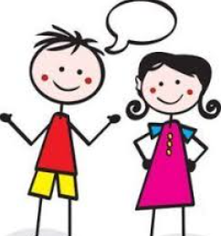
Day 9  If you could have an animal butler for the day what would it be? Can you draw it, label it and give it a name?  Day 10  Ask your child to pick their butler and label them e.g.  If I pick a hedgehog butler; I will label spikes, eyes, nose etc., try and get your child to think of an adjective to describe the parts they are labelling e.g. ‘Tiny wet nose’ or ‘sharp spikes’. If they can write the adjectives encourage doing so. If not stick to simple label and just talk about adjectives with your child.  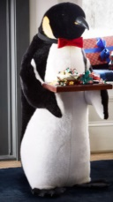  Then give their butler a name! | The Queen’s Orangutan  2 Week English Plan |  | Day 5  The queen signs her letter; practice your signature on a piece of paper!  Ask your child to write their name as neatly as possible. If they need some extra help; write their name for them in a yellow pencil and get them to write over the top; practice a couple of times.  
Can you make an Orangutan fact file? Day 6, 7 and 8
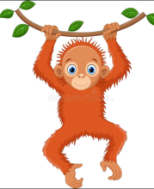
Ask your child to do some research at home and make a fact file about orangutans. Encourage to include pictures, drawings and key facts! (what do they eat? Where do they live? Are they a mammal/reptile/amphibian etc.?
Please spend a few days working on this project.

