DAY 1. Watch the video of ‘King Jack and the Dragon’.  King Jack and the Dragon | Storytime! - YouTube  Ask your child some questions about the story e.g.  - Who is the author (on front cover)  - Who is the illustrator? (Helen Oxenbury, second name on front cover)  - What do the author and illustrator do? Author writes the story, illustrator draws the pictures.  - Where have the dragons and the beasts in the story come from? (the children’s imagination)  - What would you imagine if you were playing castles? |  | DAY 2. Can you draw a castle using your imagination? What does it look like? Upload a picture to dojo if you can!  DAY 3. Adult help needed. Adults, ask your children to use their sounds to write these castle words… bridge, moat, sword, king. If the children use their sounds the words should look like this… brij, moat, sord, king. Don’t worry that they aren’t spelt correctly, at this age your child should be using sounds in this way.
DAY 4. Can you write a list of things you would need to build your own castle/fort?  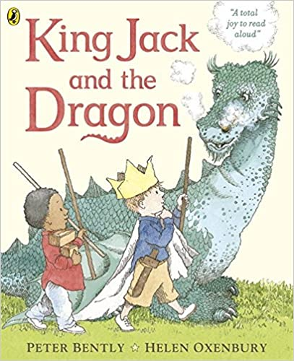  DAY 5. Can you tell your grown up how to build castle/fort? Adults, please write your children’s ideas down.  DAY 6. Using your ideas from yesterday, can you write instructions on how to build a castle/fort?  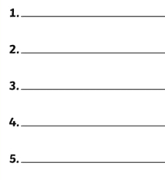  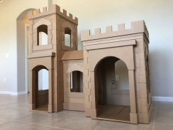  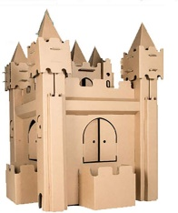 | King Jack and the Dragon  2 Week English Plan | DAY 7. Can you draw your own dragon using your imagination? Can you colour it in and give it a name?  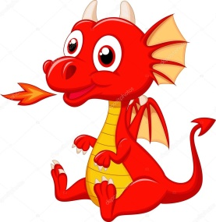  DAY 8. Can you write at least 5 adjectives (describing words) to describe your dragon? These can be what the dragon looks like or about their personality e.g. huge, fiery, sharp-clawed, friendly, happy, kind. Try and use really exciting words!
DAY 9. Can you write a sentence (or more!) to describe your dragon using the adjectives you wrote yesterday? E.g. My dragon has huge, red claws. My dragon is friendly and helpful. My dragon has strong, powerful wings.

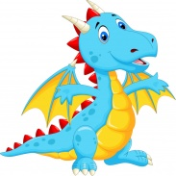
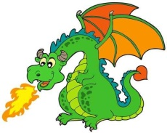
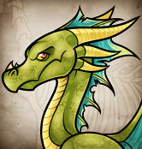
DAY 10. Design your own front cover. You can even re-name the story to your name! Take a picture and upload it to dojo if you can!


