  We are now a month into our new year. What would you like to get even better at this year - what is your goal? Draw this as a picture and label what it is. See if you can answer these questions - What you enjoy doing? What do you find a bit tricky? What are you going to try and get better at? How will you do it? What do you think you have got better at this year already? | Computing/Technology    Listen to the story of Zog the dragon - ZOG - By Julia Donaldson. Children's illustrated audiobook. - YouTube Imagine you are Zog with his friends, flying in the blue sky. Can you take an aerial photo of objects around your house as if you were looking at them from above? |   Soon we will be seeing signs of spring! Can you name 5 plants in your garden or when you are out for exercise?    Choose from the Science activities in the learning folder to see if you can label parts of a flower, build your own flower and sequence the growth of a plant! | In our story Zog, the Dragons are learning how to breathe fire. Your challenge is to design your own fire breather! Test it to see if you can use it to blow a small object! You need to think about what your small object will be - will it be heavy or light? What you are going to use as your fire breather? Here are some ideas - rolled up paper, a straw or an old kitchen roll. Have a think about what will be the best surface to test your fire breather! Can you decorate your fire breather?
Religious Education    On the 12th February it is the beginning of Chinese New Year. Take a look at the story of the 12 animals of the zodiac here: https://www.youtube.com/watch?v=eVClAj8q_lY Can you write and name as many animals in the Chinese Zodiac? Then find out when you were born - what animal is your zodiac? Can you find the zodiac animals of your family members? | 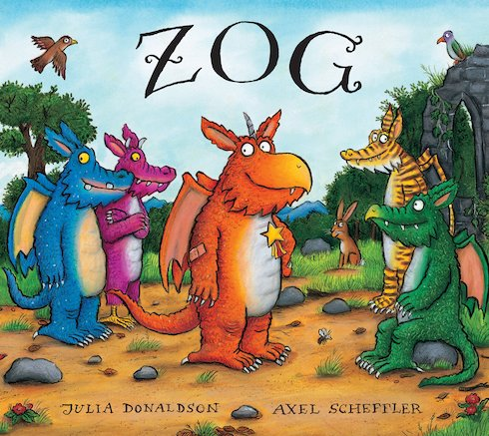 |  | 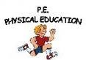  Continue to follow any of the following on Youtube: Cosmic kids yoga, Jump Start Johnny or PE with Joe Wicks.  Challenge - Find yourself a target in the garden – a bucket, pot or even the wheelie bin! You will also need a ball/bean bag/small object to throw. Start close and each time you get it in your target take one step back and go again. If you miss take one stop closer and try again. See how far back you can get!
  Song time! Can you listen to and try to learn the first verse of our National Anthem? UK National Anthem Lyrics HQ - YouTube  Can you sing the song ‘There was a Princess’? https://www.youtube.com/watch?v=5kMgzpmYFkM |   Choose any British monarch (that’s a king or a queen) in History and write at least 3 facts about them! Can you draw a portrait of them too? |   Imagine Zog flying above your house and looking down – what would he see? Can you draw a simple aerial view of your house? If you can, try to use a simple key or label to show what you have drawn. | 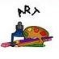  In our story, Zog is trying hard to win a Gold Star. If you could give Zog a reward, what would you give him? Draw your reward for Zog and label it. It could be a sticker, a certificate, a medal or even a special trophy!

