. Please listen to the story ‘ Chocolate Milk, Por Favour’  https://www.youtube.com/watch?v=idGcvzb4hnY  Then please ask your children the following questions and write in their books.  -Why was Gabe upset when he got to school?  -Why didn’t Johnny want to be Gabe’s friend?  -What did Gabe teach Johnny?  -How do you think the boys felt at the end? | Can you try and split our story in beginning, middle and end?  Grow up cheat sheet:  Beginning: Gabe started a new school and Johnny thought he was a cry baby.  Middle: The other kids started including Gabe and Johnny felt left out.  End: Gabe helped Johnny do a football trick that he had trouble with. | At the beginning of the story Johnny didn’t want to be friends with Gabe because he was a ‘cry baby’ and could speak the same language.  Please watch this video about how to write a persuasive letter  https://www.youtube.com/watch?v=hD9arWXIddM  Can you write a letter to Johnny to persuade him to be friends with Gabe? | Can you follow instructions to make chocolate milk?  https://www.thespruceeats.com/chocolate-milk-recipe-2355494  Here is a simple recipe and ingredients for making chocolate milk.  Remember to send a picture of your chocolate milk!
Can you remember a time you cried/wanted to cry?  What made you want to cry? Can you use this feelings word mat to help you describe how you felt.  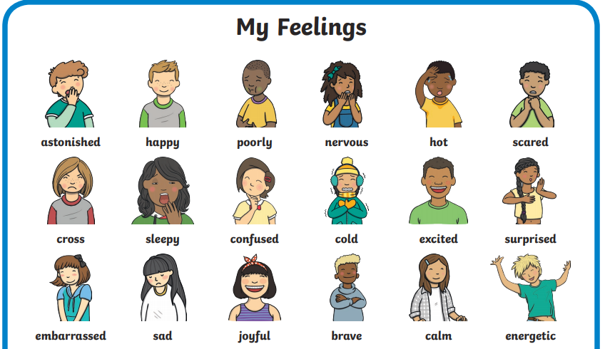  Go through the different words with your grown up to see what they mean if you don’t know. | 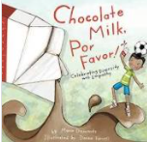 |  | Similarities and differences  Can you find similarities and differences between:  -Gabe and Johnny  -You and Gabe  -You and Johnny  Draw a picture of you, Gabe and Johnny and write your similarities and differences underneath
Can you design your own chocolate milkshake?  Draw your dream chocolate milkshake with all the toppings and label them!  I think mine would have cream, brownies and sprinkles on the top! | Can you create your own book and recreate your own ‘chocolate milk, Por favour!’ book.  Use illustrations (drawings) to remake the story book! Make sure you put the story in the right order! | What is a skill that you have you could share with someone else? Can you teach your brother/sister/grown up how to do your skill?  Remember - Give clear instructions. | Can you find words that include the sounds you have been learning this week in phonics and write them out in your book?  Make sure to ask your grown up if you don’t know what that word means.

