Time | Activity
9:00 – 9:30 | Good morning  Wake and shake (Jumpstart Jonny, go noodle - Youtube)
9:30 – 10:00 | Phonics (See Class Dojo links)
10:00 – 11:00 | Break
11:00 – 12:00 | Maths (See activities below)
12:00 – 1:00 | Lunch time
1:00 – 1:15 | Wake and shake
1:15 – 2:00 | Complete a blue activity
2:00 -3:00 | Complete a yellow OR green activity
3:00 | End of day story

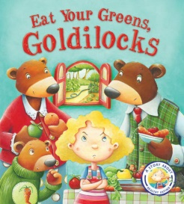
This week we will be focusing on healthy living so will be looking at the stories, The very hungry Caterpillar, Eat your Greens Goldilocks and Oliver’s Fruit Salad.
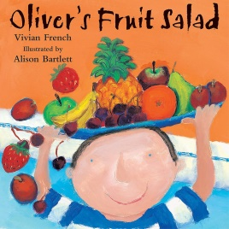
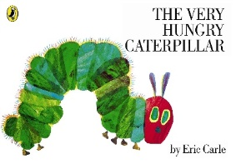

Maths: Growing 6, 7 and 8!
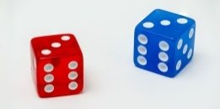
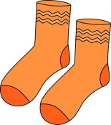
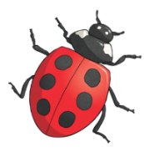
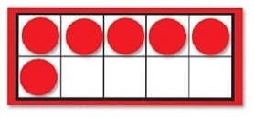

Jigsaw theme:
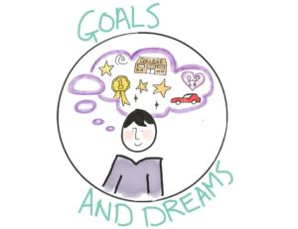

Maths  Use the maths pictures below to help you | We are carrying on with our learning about 6,7 and 8.  Can you play a memory game (see Monday slide below) Your grown up will need to draw ladybirds with two ways to make 6, 7 and 8. Turn the cards over, take it in turns to turn the cards over. Does each card show 6? If they both do, then you have found a pair, if not turn them back over and have another go. | Making Pairs  A pair is when we have 2. Can you go around your house a find some things that make a pair, for example a pair of socks, a knife and fork, a pair of teddies etc.  Can you make 6 pairs, 7 pairs and 8 pairs of things?  If you go on a walk later, have a look at things around you to make some pairs. Remember a pair is when we have 2. | Combining 2 groups  Using some objects like teddies, counters or fruit. Count out 5 objects and make a group then count out 3 objects and make another group, You should have 2 groups. How many objects do you have altogether? Try this a few more times using different amounts in your groups.  Below in the picture have a go at combining two groups. | Combining 2 groups  Using the Tens frame modeller  http://www.ictgames.com/mobilePage/tenFrame/index.html  Use the green and red counters. Your grown up needs to put an amount of green counters onto the tens frame by tapping on the green counter then put another group of red counters onto the tens frame. How many do you have altogether? Try this a few times. | Adding more  Create your own number track on a piece of paper or cardboard 1-12.  Roll two dice. How many spots do you have altogether? Can you predict what number you will land on? How many more spaces do you need to move to win the game? (See game below)
Maths songs | In the story of The very hungry Caterpillar it tells us about the days of the week. Have a go at singing the days of the week song at we do at school.  https://www.youtube.com/watch?v=3tx0rvuXIRg | One potato, two potato song  https://www.youtube.com/watch?v=6poj1mR_cRY | Days of the week song  https://www.youtube.com/watch?v=oKqAblcwFOA  After the song, talk about what day it is today? What day was it yesterday? What day will it be tomorrow? | I like counting fruits song –  https://www.youtube.com/watch?v=J_i6o1194tM | Days of the week song  https://www.youtube.com/watch?v=36n93jvjkDs  Get your grown up to write the days of the week on some paper, cut them up and see if you can put them in order, try singing the song to help you.
Physical development  Health and Self Care | Challenge Time – Eating Well.  This week we are challenging you to eat lots of different coloured fruits and vegetables. Can you eat a Rainbow?? Can you name fruits of vegetables of different colours? Paint or draw the rainbow and complete the challenge. Information Below.  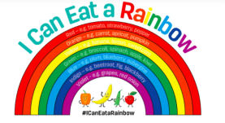 | What does the word Healthy mean? What do we need to do to be healthy?  Watch the video and discuss with your grown up ways you can be healthy. Can you draw some pictures of the things you do to stay healthy?  https://www.youtube.com/watch?v=UxnEuj1c0sw  Challenge: Do you know what having a balanced diet means? | Exercise  Cosmic kids Yoga Poses  https://www.youtube.com/watch?v=zMHOgzFTPSg  Just Dance  5 little monkeys – Just Dance  https://www.youtube.com/watch?v=vKnwqgBINXk  I like to move it, move it!  https://www.youtube.com/watch?v=ziLHZeKbMUo  Get moving and go outside! (list below) | Be Healthy  Hand Washing, Brushing your Teeth and sleep  These are very important ways of staying healthy.  Can you practise singing this song when you wash your hands? (See song below)  How many times should you brush your teeth a day? What would happen if you didn’t brush your teeth? Have you ever been to the dentist? What happened when you went there?  https://www.bbc.co.uk/cbeebies/watch/zingzillas-brush-your-teeth  Why is getting enough sleep important? Tonight why don’t you share a bedtime story with your grown up. Before you go to sleep tell your grown up something you enjoyed doing today. | Using two plates and a variety of foods from your house. Can you sort the food into healthy and unhealthy?  Think about foods that have lots of sugar or salt in? They will be unhealthy.  Discuss with your grown up about have a balanced diet.  It is ok to have things like chocolate and sweets as a treat.  What treats do you like to eat?
Jigsaw -  Personal, social and emotional development  What are we learning?  I can say how I feel when I achieve a goal and know what it means to feel proud. | During our Jigsaw sessions we have been talking about our goals. What do we want to get better at? It could be writing your name, riding a bike, zipping up your coat, counting forwards/backwards to 10.  Have a think about something you want to want to get better at doing and work on it this week. | What does the word Proud mean?  To feel proud, you feel pleased about something good you have done, or about something good that a person close to you has done.  Watch the story of Giraffe’s can’t dance and talk about what Gerald did that made him proud.  https://www.youtube.com/watch?v=Zzb5Acl-n70 | Mindfulness Meditation  Have a go at some mindfulness mediation with your grown up.  https://youtu.be/Bk_qU7l-fcU | Draw a picture of a big white fluffy cloud and talk about the things that you are proud of, the things you have achieved.    Have a go at drawing some pictures in your cloud of the things you have achieved, even label your picture of write a sentence about it. | Mindfulness Activities you can try.  - Bubble Balloon Game  Blow up some balloons and play don’t touch the floor game, but focusing on gentle movements. Pretend the balloons are bubbles that might pop, so you can only tap them delicately.  - Texture Bag  Put a selection of objects with different shapes and textures into a bag. Take turns putting your hands in, feeling one of the objects and describing it to the others without looking at it.  - 5 finger breathing  https://www.youtube.com/watch?v=DSgOW879jjA
Communication and language  Be Creative – EAD | Listen to the Story Oliver’s Fruit Salad.  https://www.youtube.com/watch?v=jcTprkImlmI  Which fruits do you like? Ask your family about their favourite fruits? Are there any fruits you don’t like or haven’t tried before? Maybe you could try a new fruit this week. | Create a shopping List  Listen again to the story Oliver’s fruit salad, and talk with your grown up about the fruits in Oliver’s trolley.  Can you choose 5 fruits and draw a picture of them and label them. Remember to say each word, stretch it out and write down the sounds you hear. | Fruit Salad  Using your shopping list go to the shop with your grown up or use some fruits you have in your house and create your own fruit salad.  Try and describe the taste, the smell, the touch of the fruits. Post a video on your portfolio of you talk about your fruit salad. | Eat Your Green’s Goldilocks.  Video of story to be posted onto class dojo page on Thursday morning. At the end of the story, the teacher will ask you some questions. Have a think about your answers and discuss them with your grown up. | Be Creative  This is a famous picture by the artist – Giuseppe Arcimboldo  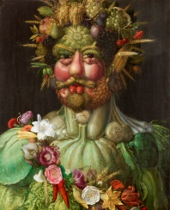  He used food to create his art.  Could you have a go at creating a face using food?
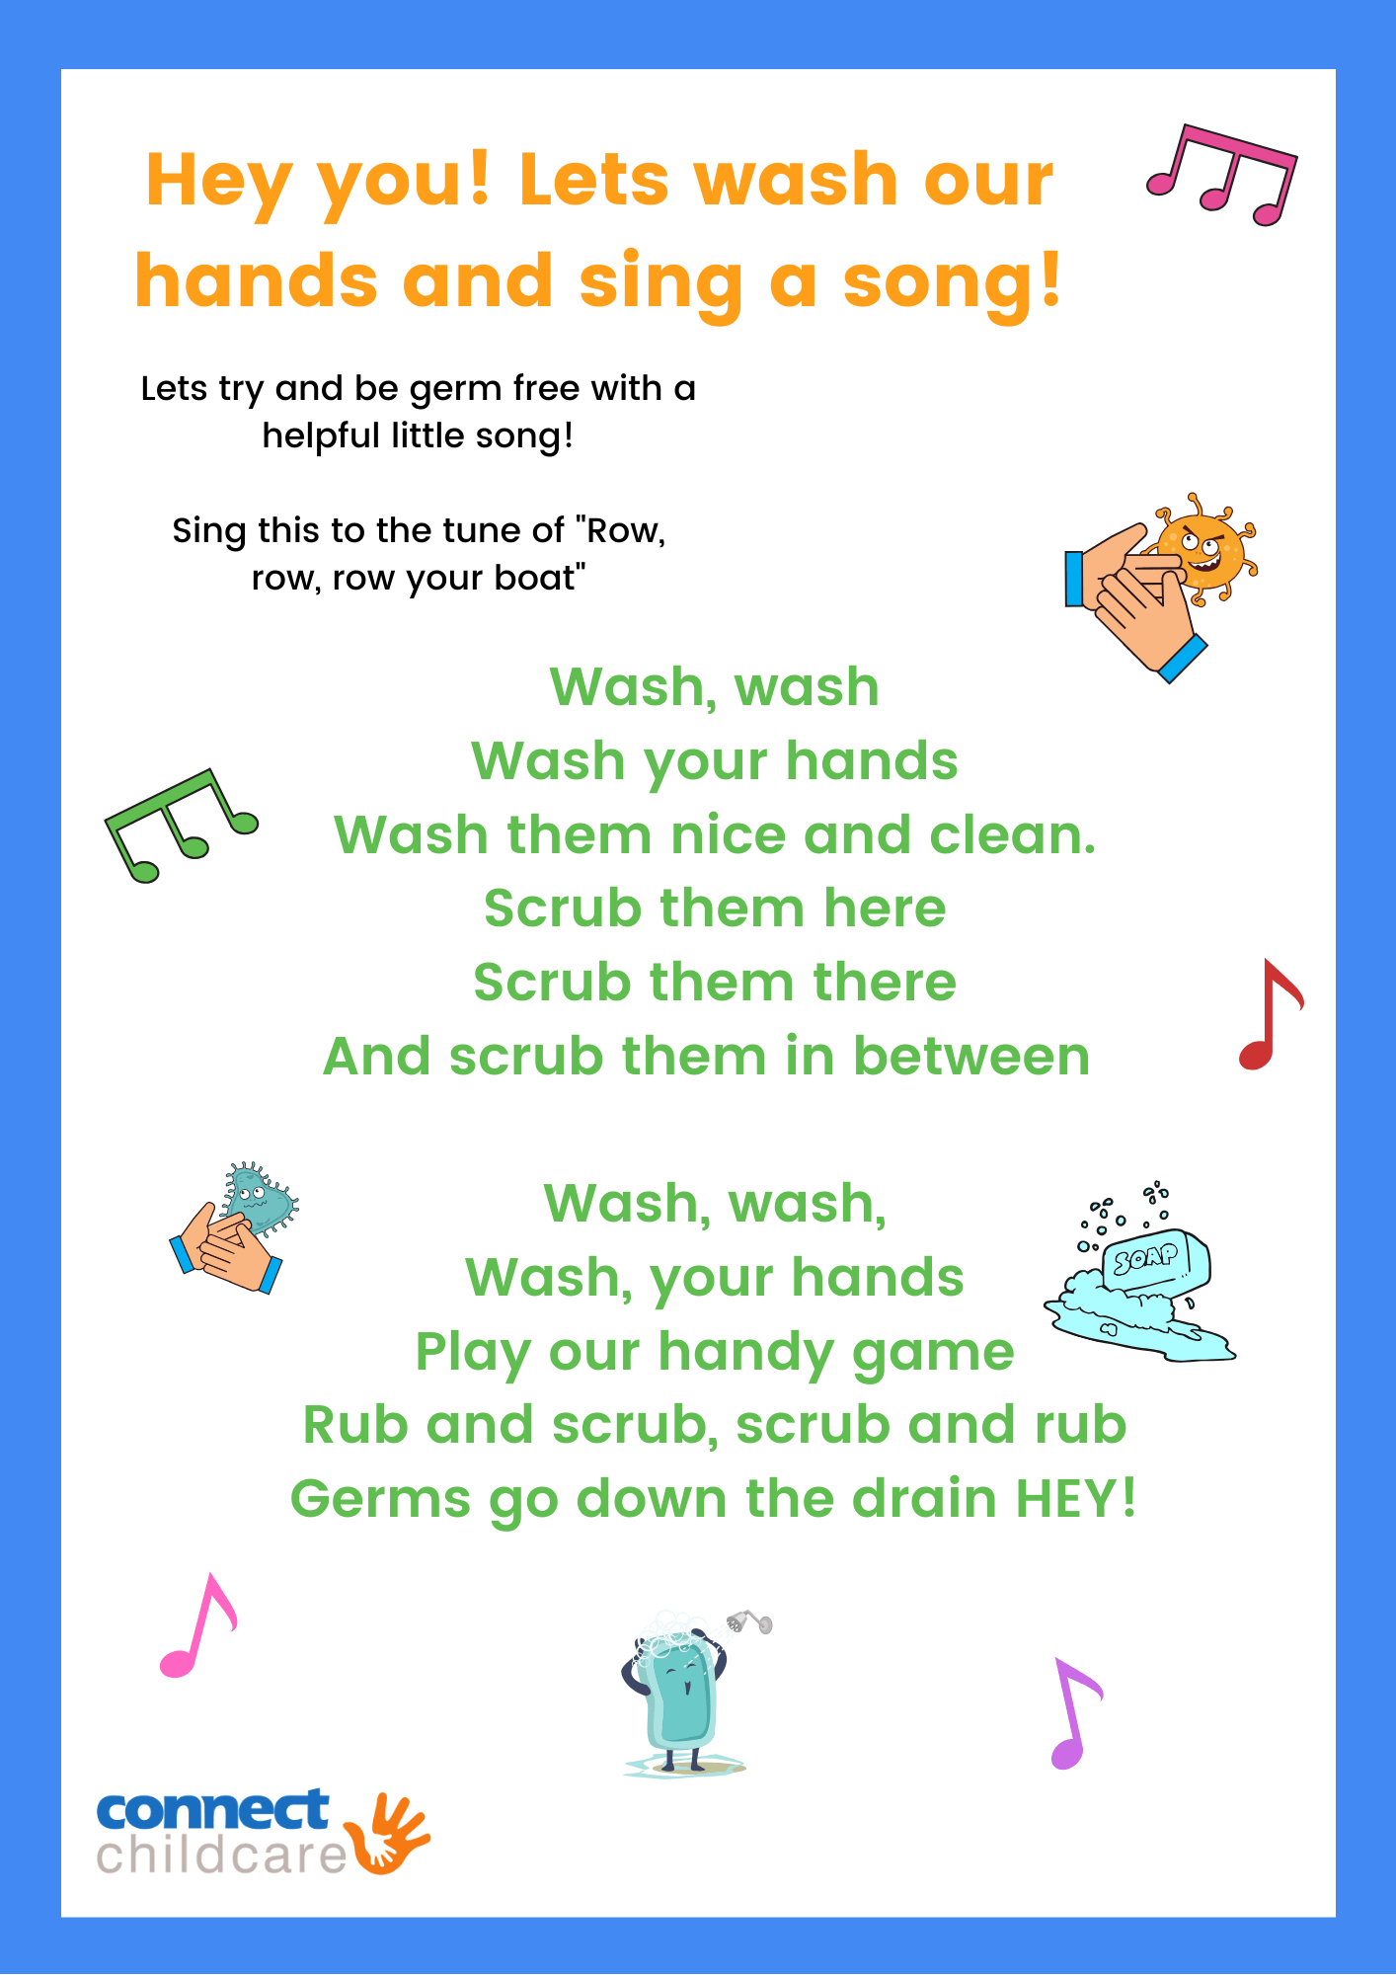
Get moving and go outside!
Traffic light game
- Red - Stop
- Yellow - Run on the spot
- Green - Run around the area
- Roundabout - turn round once
- Motorway – sprint
- Traffic Jam - walk or slowly jog
- Lollipop person - put hands out in front of them and shout "stop"
- Police Car - Sit on floor and spin round shouting "nee naw nee naw"
Chalk obstacle Course
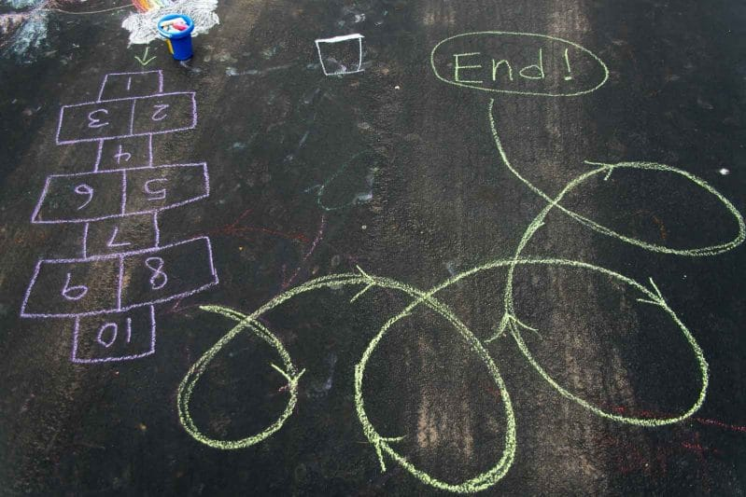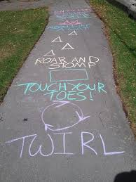

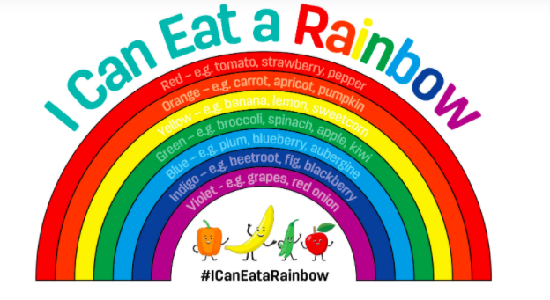

Fruit and Vegetables
Red
Orange
Yellow
Green
Blue
Purple

Create your own table and every time your
child eats a coloured fruit or vegetable
record it in the table. By the end of the week
hopefully they will have eaten a rainbow.
On Friday 12th February it is Chinese New Year. We will be learning about this festival in school. If you would like to find out more about Chinese New Year there are some great videos on Cbeebies you can share with your child. https://www.bbc.co.uk/cbeebies/watch/chinese-new-year?collection=chinese-lunar-new-year

Monday Wednesday Friday


