Time | Activity
9:00 – 9:30 | Good morning  Wake and shake (Jumpstart Jonny, go noodle - Youtube)
9:30 – 10:00 | Phonics (See Class Dojo links)
10:00 – 11:00 | Break
11:00 – 12:00 | Maths (See activities below)
12:00 – 1:00 | Lunch time
1:00 – 1:15 | Wake and shake
1:15 – 2:00 | Complete a blue activity
2:00 -3:00 | Complete a yellow OR green activity
3:00 | End of day story

Core story: Dear Zoo by Rod Campbell
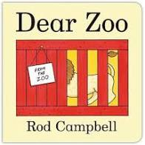
Maths: Counting and representing numbers.
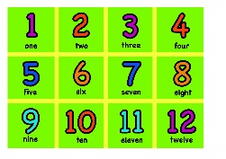
Jigsaw theme: Dreams and Goals
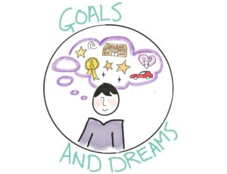

Maths | The frog in Dear Zoo was too jumpy!  Sing some counting backward number songs such as 5 speckled frogs using your fingers to take one away as they jump into the pond.  https://www.bbc.co.uk/teach/school-radio/nursery-rhymes-five-little-speckled-frogs/zjjbnrd | Help Curious George the monkey find and count the animals in this game of hide and seek!  https://pbskids.org/curiousgeorge/busyday/hideseek/ | Use scrap paper and draw dots to represent numbers 1-6 (see image).  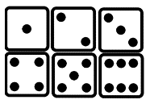  Mix up the squares. Can you find the one with 4 dots?  Can you find one with more than 4 dots? Which pictures have less than 4? Can you put the dots in number order?  Challenge: Hide a picture.  Can you work out which one is missing? | Pretend you are a Zoo animal for this Maths game!  For example, Can you be a frog and show me 4 jumps, 1 jump, 0 jumps, 2 jumps?  Can you be an elephant and show me 3 stomps, 5 stomps, 10 stomps and 6 stomps.  Can you be a lion and show me 3 roars, 1 roar, 0 roars and 4 roars.  Challenge: Can you think of any more counting actions for the rest of the Zoo animals in the story? | For this activity you will need some number cards (numbers on scrap paper will do!)  Draw some Zoo animals and create your own mix and match game to 10 or even 20!  For example, 1 =   2=   3=
Physical development | Dear Zoo – Can you find different ways to move like the Zoo animals from the story e.g. Stomp, run, hop, slither, jump etc  Which way is easier to travel and move about? | Finger gym is super important as it helps make our fingers strong so we become wonderful writers. Try this finger exercise song below.  https://www.youtube.com/watch?v=6RU6pBT-OAo&list=PLOcPymb-OvBzRZZ5RUMWhW_USBIqIlHll&index=3 | Balancing bodies – Try some Zoo animal yoga poses (See pictures attached at the bottom) Or try this cosmic safari yoga link  https://www.youtube.com/watch?v=C4CaR0syf1  Which is your favourite animal pose? Did you find any really tricky? | Make some paper chain snakes. Use strips of paper, card or ribbon to make interlocking rings to make snakes of different lengths. | Playdough – make some playdough (recipe below). Can you make the animals from Dear Zoo?  Playdough is really good for your finger/hand muscles.  No playdough? That’s fine draw some Zoo animals and colour them in to make a lovely picture.
Jigsaw -  Personal, social and emotional development | Talk about what never giving up means. Can you think of a time you found something tricky that took practise but you managed to do in the end? For example riding a bike.  Talk about not giving up even when things get hard. Making mistakes helps our brain to grow! | Challenge.  Can you think of something that you find tricky? Maybe it is writing your name or counting to 20. Try practising it for a few minutes each day and let us know how you get on at the end of the week. | Mindfulness.  Take some time out to relax and forget about your worries. Maybe try the cosmic yoga, or go for a walk with your family, do a puzzle or some colouring together. | Sing!  Sing some of your favourite songs and nursery rhymes!  Make up actions, dance with ribbons or play some instruments and have fun! | Be creative!  Use recycling boxes (turn inside out) to paint, draw on and colour!  Can you turn an empty cereal box into something wonderful? Maybe you can create a Zoo house for your favourite zoo animal.  Have fun creating!
Communication and language | Act out Dear Zoo.  Can you pretend to be the animals jumping out of the delivery boxes as a surprise!  Maybe you can make some colourful animal masks to role play the story. | Let’s learn about snakes!  Miss Bond has a pet Snake called Allan! She will be posting a video of him. Please comment on the video to ask her lots of questions about Allan and what kind of care he needs. | Try the game  What’s through the binoculars?  The game will be posted on the main class page as a PowerPoint activity. | Talk about your favourite Zoo animals? Which animals would you send back from the story? Which Zoo animal in the story would you keep?  How difficult would it be to keep a Giraffe as a pet?  Can you research three facts about your favourite Zoo animal? | Can you design and draw your own zoo in a picture.  Can you describe your Zoo picture to another person? Which animals have you put in your zoo?  Penguins will need a pool area to swim and elephants will need a lot of room to stomp.



