Time | Activity
9:00 – 9:30 | Good morning  Wake and shake (Jumpstart Jonny, go noodle - Youtube)
9:30 – 10:00 | Phonics (See Class Dojo links)
10:00 – 11:00 | Break
11:00 – 12:00 | Maths (See activities below)
12:00 – 1:00 | Lunch time
1:00 – 1:15 | Wake and shake
1:15 – 2:00 | Complete a blue activity
2:00 -3:00 | Complete a yellow OR green activity
3:00 | End of day story

Core story: Farmer Duck – Martin Waddell
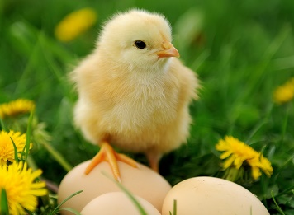
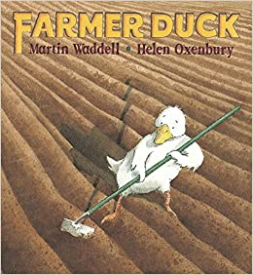
Non fiction: Introduction to Spring time

https://www.youtube.com/watch?v=9Pxx_csv40Q


Maths: Understanding 6, 7 and 8 cont.
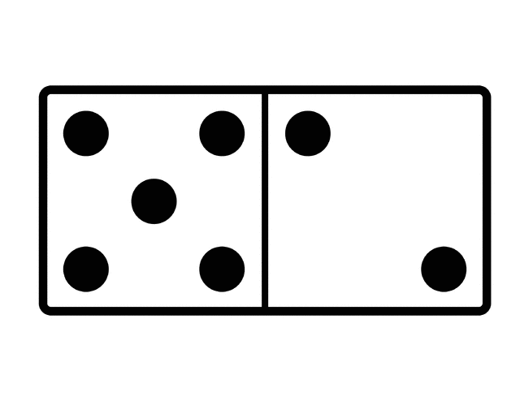
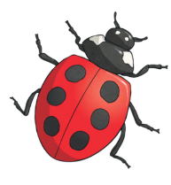
Jigsaw theme: Healthy Me


Maths  Use the maths pictures below to help you | Comparing height – taller/shorter  Building towers. Roll a dice (link for online dice below). Build a tower using that many.  Can you make a tower that is taller? Can you make a tower that is shorter? How many cubes did you use for each tower.  Challenge: Can you make a tower and estimate how many bricks you will need to make a taller/shorter tower? | Comparing length – longer/shorter  Measuring objects – choose 2 objects from around your house or from outside. Compare the two, can you see which is the longest and which is the shortest. Try this with different objects.  Measure how long your objects were. You could use pasta pieces, blocks, paperclips etc. How do you know one is the longest/shortest?  Challenge: Can you write the number and make a label for the objects? | Days of the week  Listen to the story of Jasper’s Beanstalk: https://www.youtube.com/watch?v=Da6lxY_8jmU  Recap ordering the days of the week. Make a label for each day but leave a space below:  Can you draw a picture of what happens each day from the story?  Challenge:  Can you write a key word to say what is happening? | Measuring height  We are going to be measuring something that grows.  You could plant a seed, or use a plant/flower that you already have in your home/garden.  Measure your plant every day to see if it has grown. You could keep a diary to write about how it changes.  This might be an activity that takes a bit of time, so we have to be patient.  Remember it is spring time, so look outside and see if there are any plants that are starting to grow! | Measuring time  We are going to have a go at measuring time.  Using a timer, can you set it to one minute and see how many times you can do the activities listed below:  - Write you name  - Star jumps  - Build a tower  - Run laps of a space  How did you find that? Which one was the quickest to do? Which one was the longest to do?  Challenge: Can you find another job that you could repeat for one minute?
  Monday | Tuesday | Wednesday
Physical development | Time yourself!  Using a timer, see how many different moves you can do in 1 minute. (hops, star jumps, jumps, running from one spot to another)  Try this each day and repeat on Friday. | Cosmic Kids Yoga!  https://www.youtube.com/watch?v=YKmRB2Z3g2s  Have a go at being the different animals on Old McDonalds farm. | On the farm  Can you cut the pictures out below and sort them into animals that do/don’t’ live on a farm  Can you write a list/draw pictures of them? | Finger Gym  You can do this using playdough, or find something small and soft that you can hold.  https://www.youtube.com/watch?v=DrBsNhwxzgc | Did you beat your score from Monday?  Talk about how we get better at something. Giving up or practising a little bit each day.
Jigsaw -  Personal, social and emotional development  What are we learning?  I understand that I need to exercise to keep my body healthy | Let’s get moving!  Recap how being healthy means, and give examples of how we can be healthy e.g. brushing our teeth, healthy food, exercise, looking after our brains.  Talk about how you are feeling now. Are you tired/hot/thirsty/calm/relaxed?  Do some of the exercises below for 1 minute.  Talk about how you are feeling now, and what has changed, e.g. breathing, feel your heart, red cheeks, tiredness | Dance around!  Choose a favourite song that you enjoy listening to.  Play this song and dance along using all the different parts of your body.  Can you make a dance routine?  What different moves can you do? | Wellbeing Wednesday  Spring time is a time for growth. Play some calming music and watch the video below. Start as a bean in the soil. Make yourself as small as you can. You’re going to grow into a tall beanstalk.  Remember it takes a long time for plants and flowers to grow, so when you become your beanstalk, take your time as you stand up and grow taller and taller!  https://www.youtube.com/watch?v=w77zPAtVTuI | Brain exercise  Exercising your brain is also important too! That’s how it gets stronger and ready for learning.  Warm up: Can you rub your belly and tap your head at the same time? Can you swap hands?  Get some objects from around your house on a tray. Take a look and say what you can see. The someone covers the tray and hides an object. Can you spot which one is missing?  Challenge: Try it with more objects on the tray, or by taking away more than one object. | Talk about different sports and physical activities that you like to do to get your body moving.  Can you draw and label different ways you like to move around?  Why do you like them?
Communication and language  Farmer Duck  Spring Time | Watch the story of Farmer Duck:  https://www.youtube.com/watch?v=9Pxx_csv40Q  How was farmer duck feeling at the beginning and the end? Why?  What can we do to help others at school/home? | Recap the story of farmer duck.  Can you draw a picture and talk about your favourite part of the story? Why did you like this part? How did it make you feel?  Next, can you draw a part of the story that you did not like and why? | Play ‘I went to the farm and I saw…’  Each person has to listen to what the others have said and add one another animal.  If you’re not sure about what animals belong on a farm, you could have another look at the story, or have a go at the blue sorting activity first. | Look at the video showing signs of Spring –  https://www.youtube.com/watch?v=vLAnt9__5Mg  Spring is a time for new life. What happens in the video?  Use the checklist below and go and look for signs of Spring. | Animals and their young  Watch the video showing you different animals and their babies:  https://www.youtube.com/watch?v=LBNxaFersj4  Some of these we might start to see in the springtime, as spring is a time for new life.  Which ones do you think we might see outside? Where might we find them?

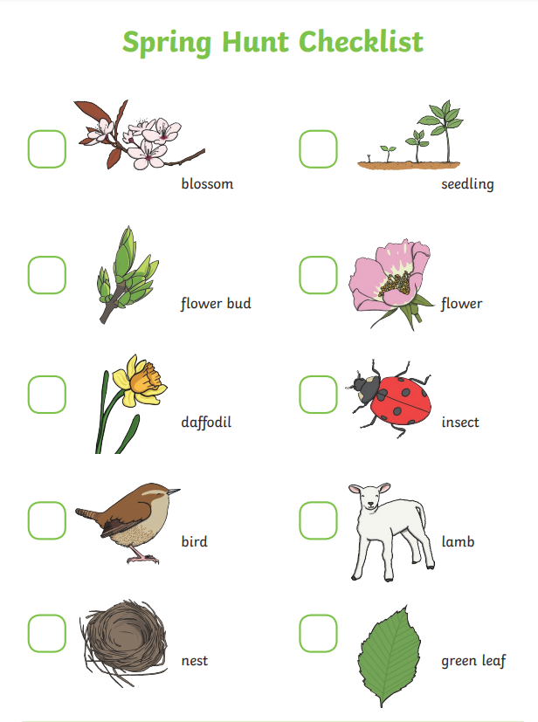
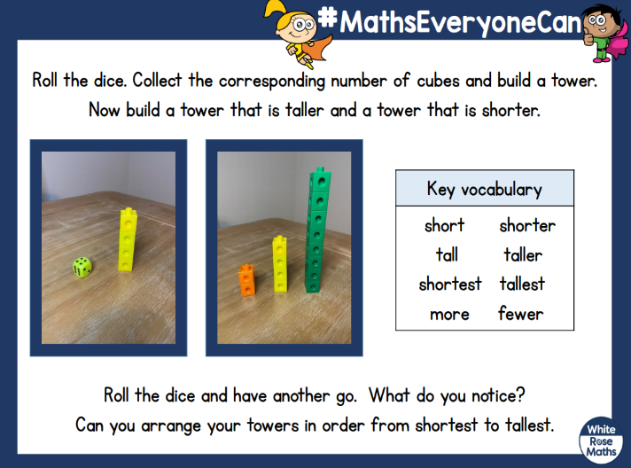
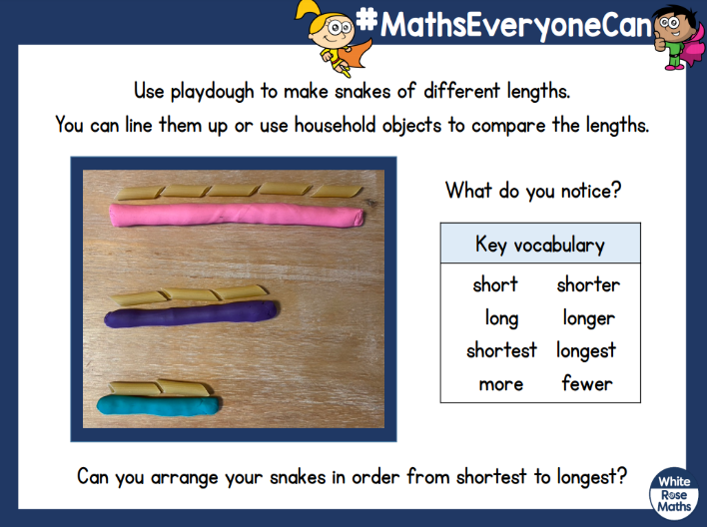
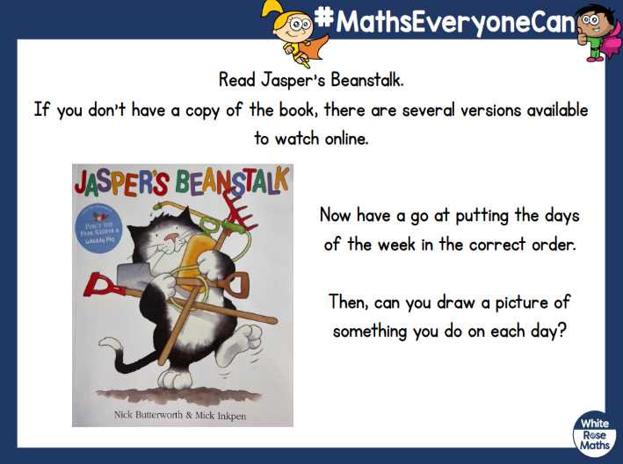
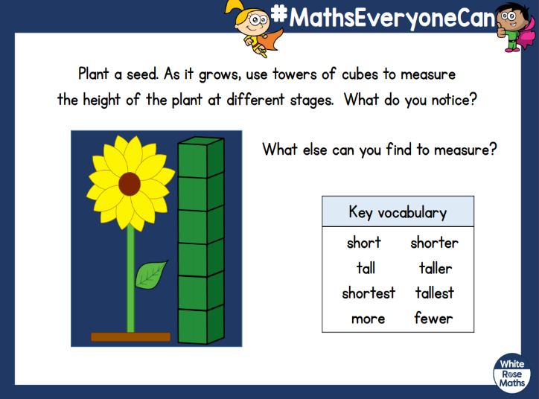
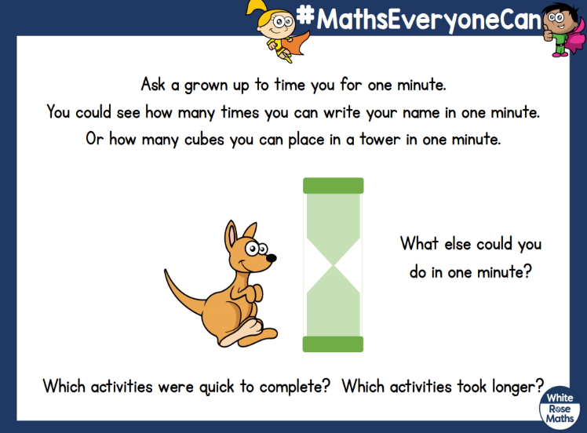

Sort the animals (lives on a farm or not)
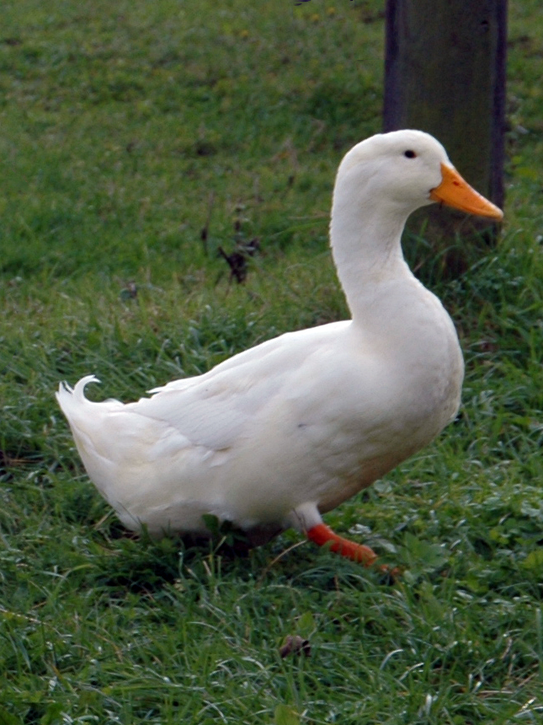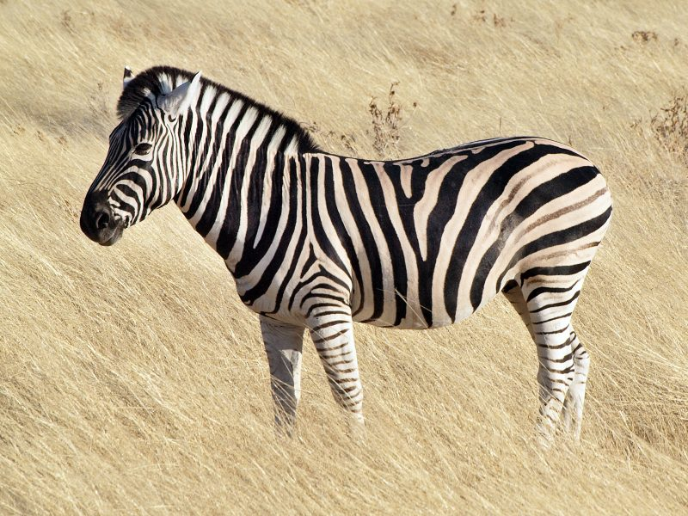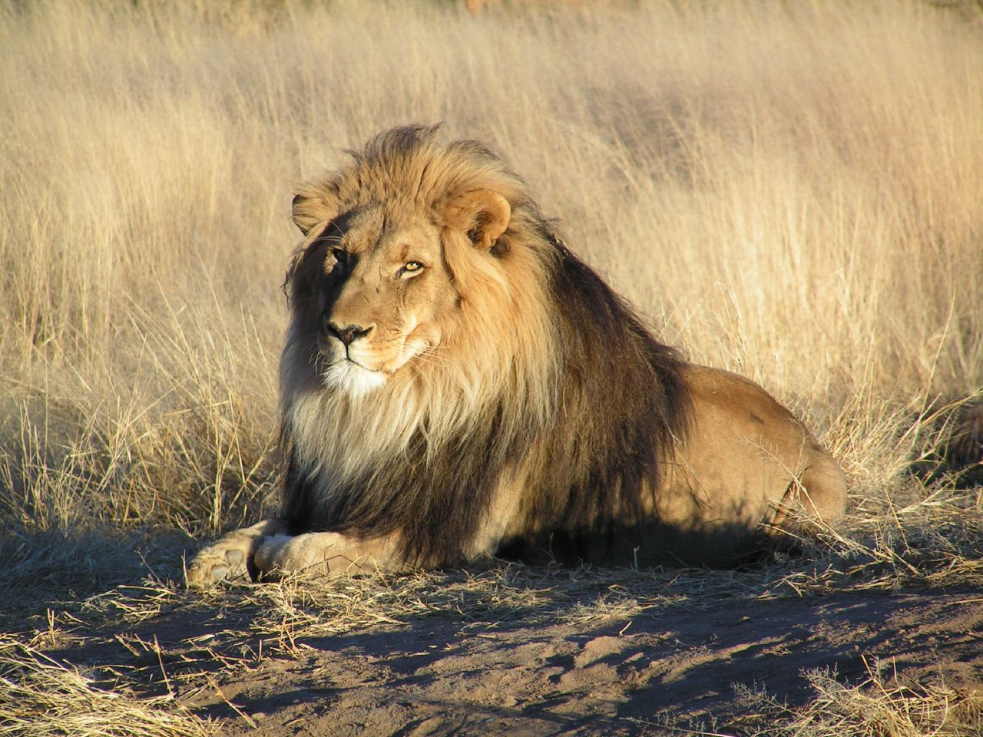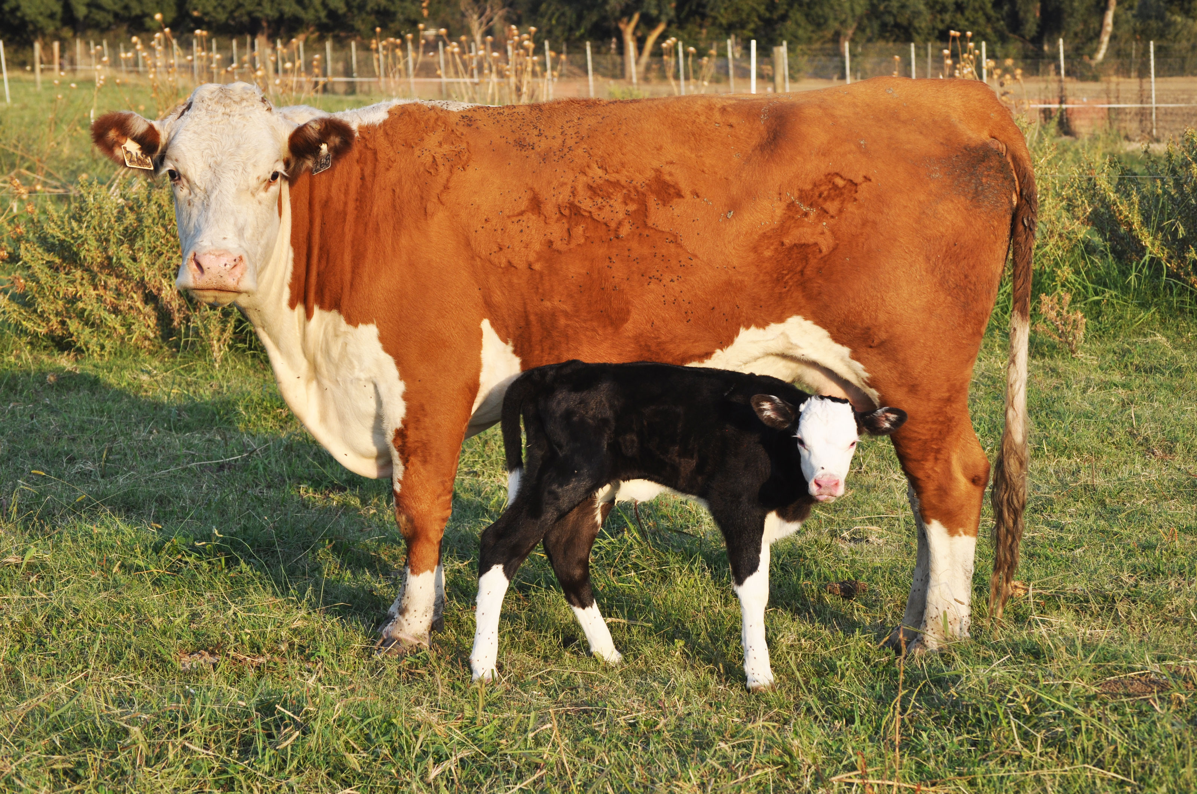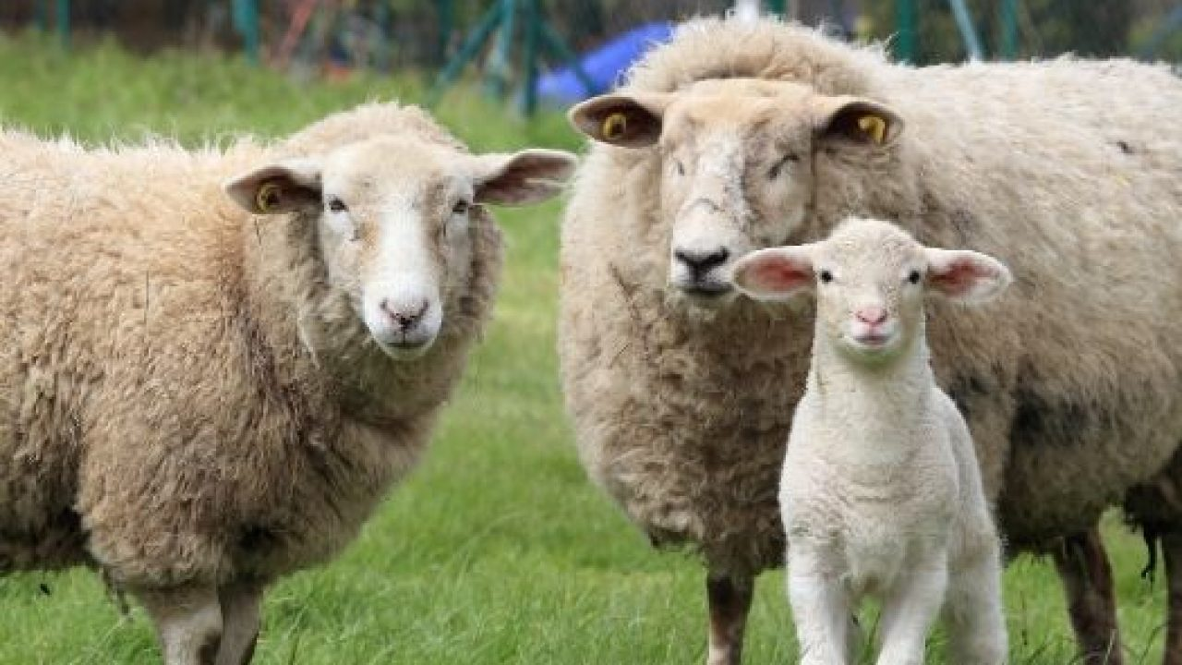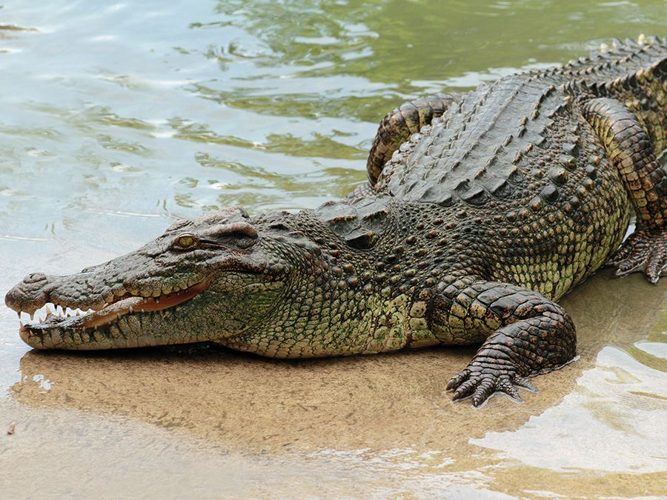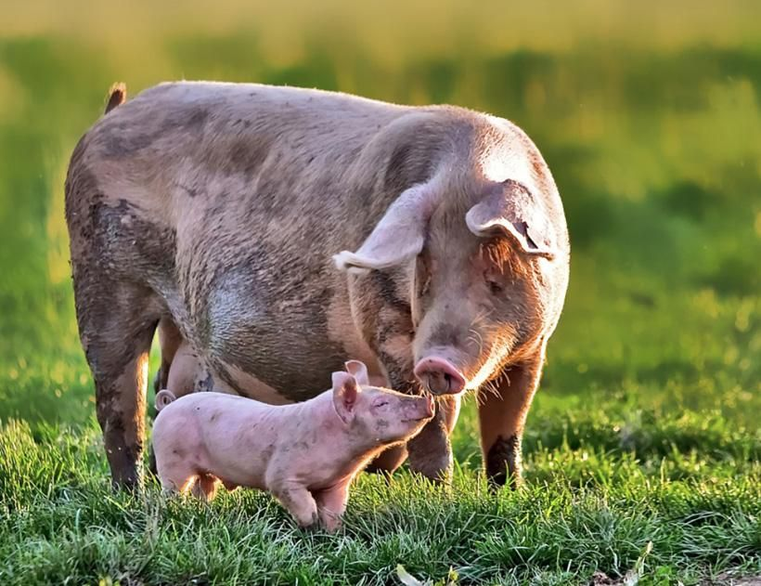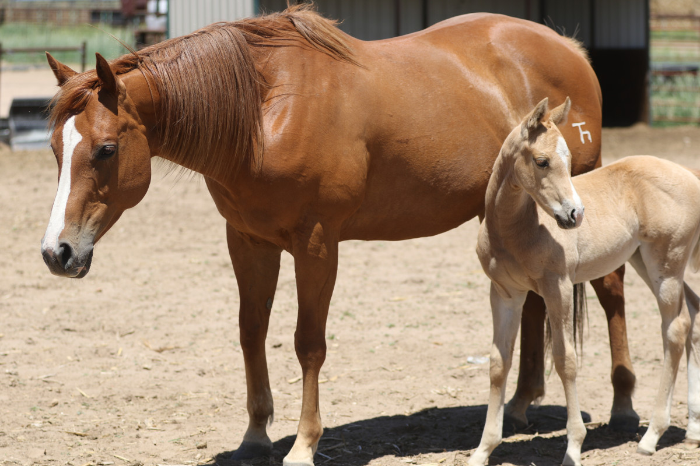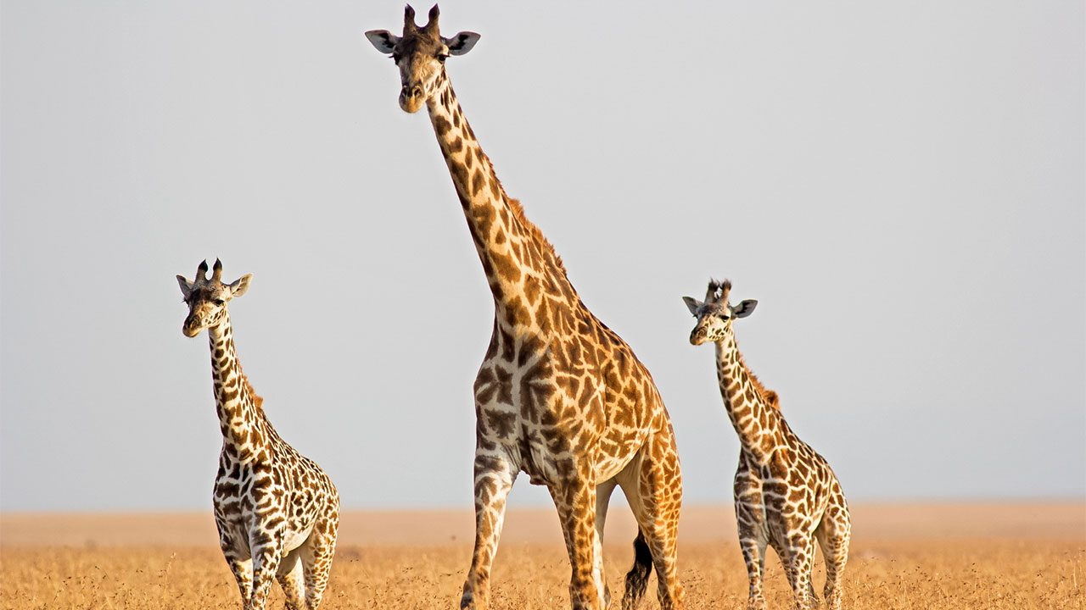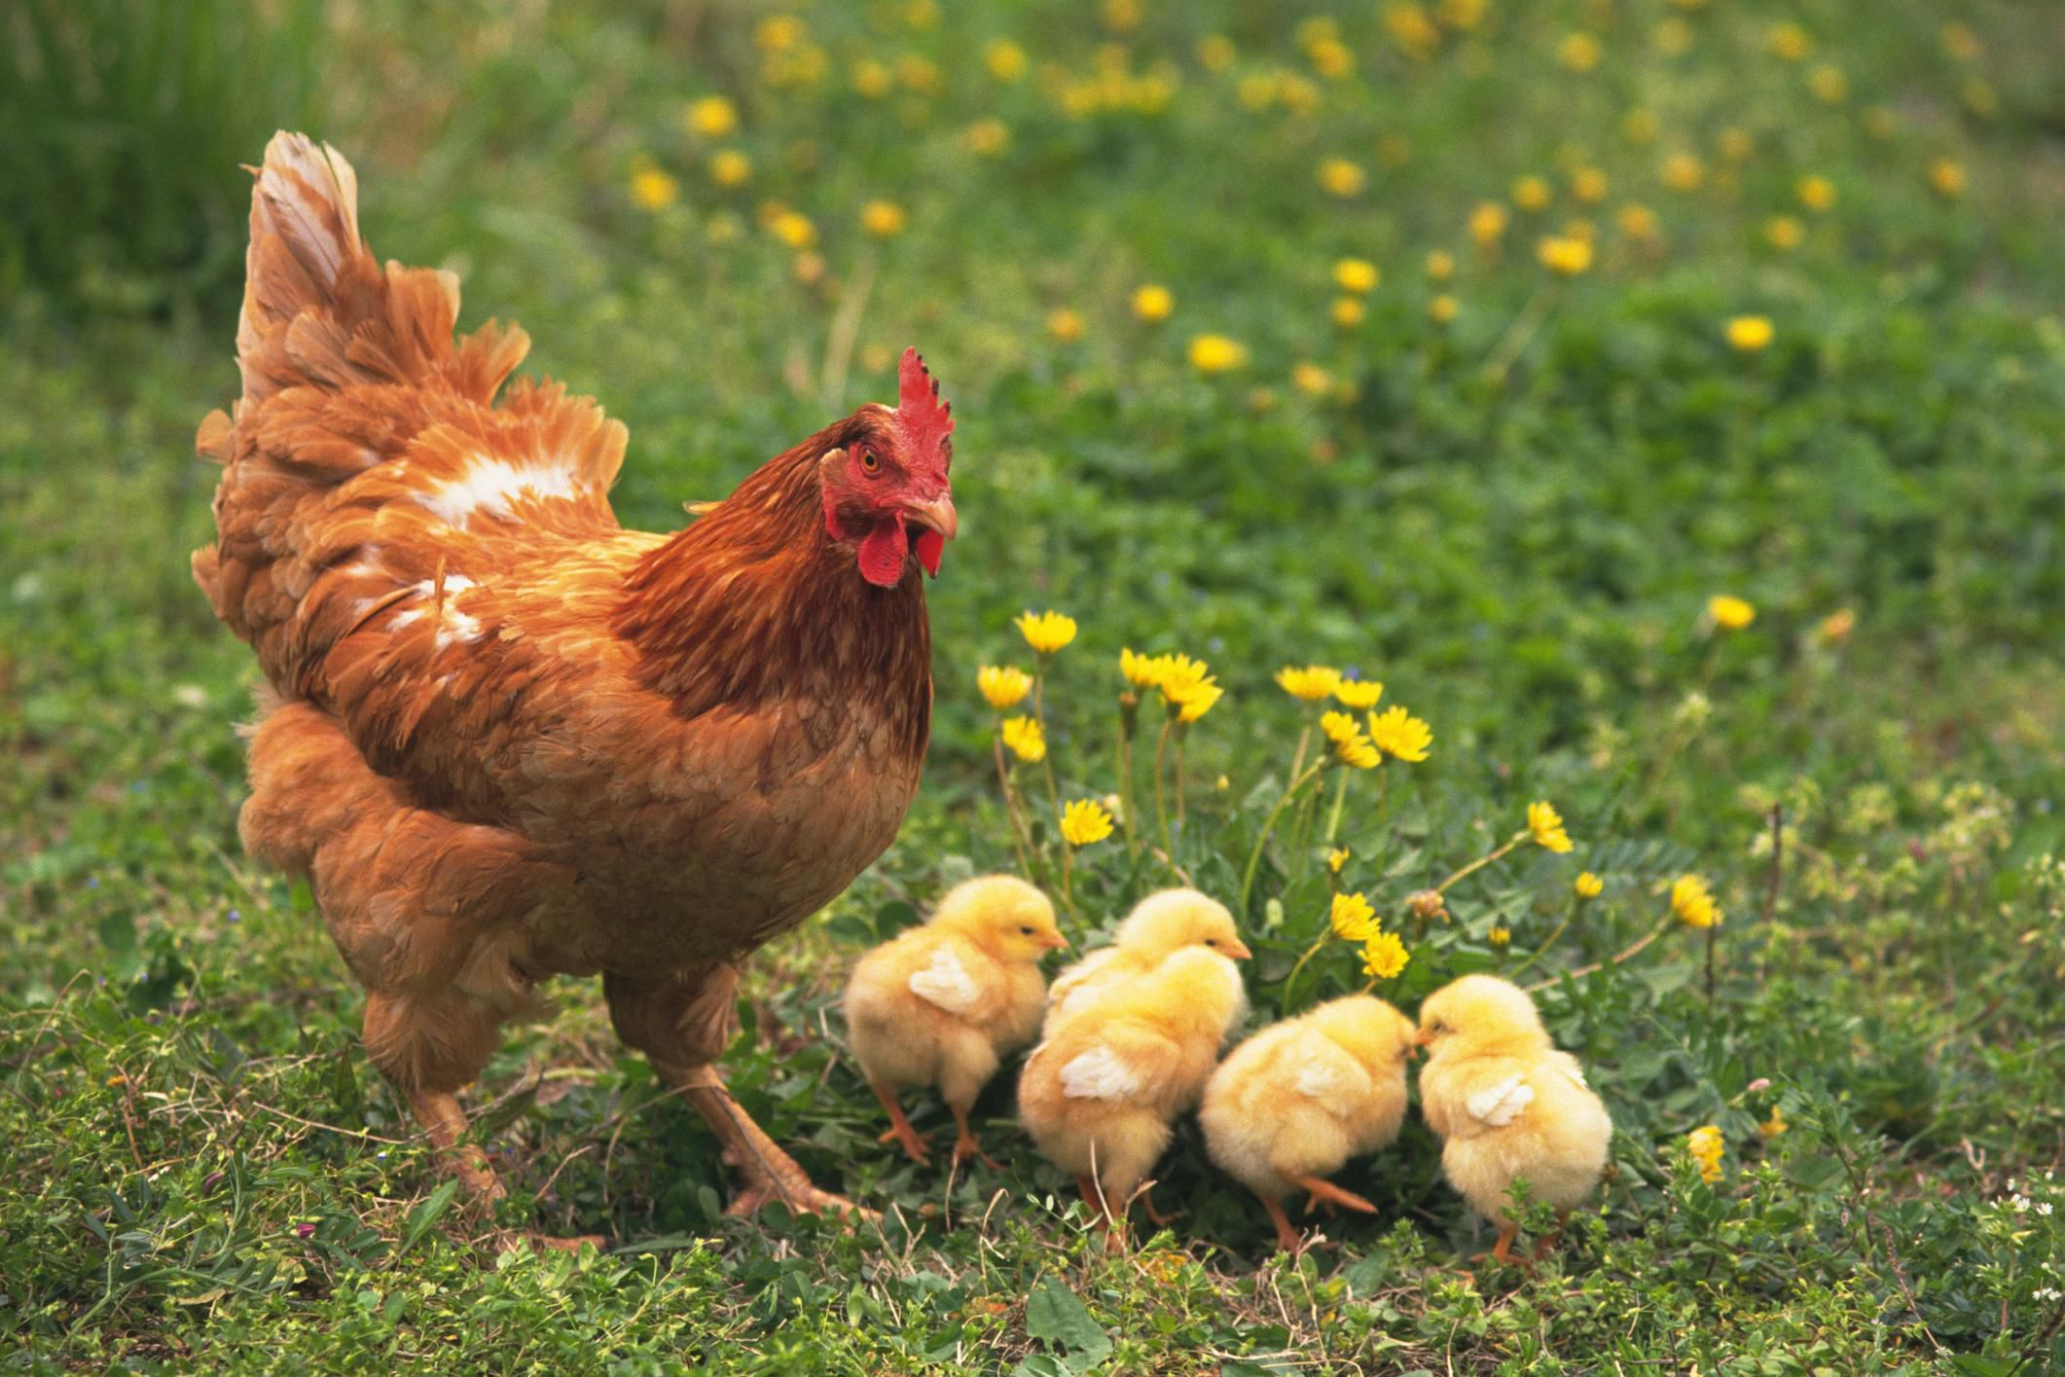
Online dice generator - https://www.online-stopwatch.com/chance-games/roll-a-dice/

