OAKWOOD INFANT AND NURSERY SCHOOL

Design and Technology Policy



Review Date
Reviewed by
Version | 1 (2022)
Review Cycle
Next review due

Signed:

Name:

On behalf of the Governing Body of Oakwood Infant and Nursery School
Introduction

At Oakwood Infant and Nursery School we aim to provide practical and hands on experience for our children to allow them to develop them innovation and understanding in Design and Technology. We encourage them to use their questioning minds in order to design, make and evaluate products, as well as reflect and review on what they produce.

Aims and Objectives

We use the National Curriculum objectives in KS1 as well as the Development Matters Guidance in Early Year Foundation Stage (EYFS) to inform planning and ensure that skills are being introduced, embedded and built upon as the children go through the school.
It states that Design and Technology enables pupils to, ‘Learn how to take risks, becoming resourceful, innovative, enterprising and capable citizens.’
The National Curriculum for design and technology aims to ensure that all pupils:

- Develop the creative, technical and practical expertise needed to perform everyday tasks confidently and to participate successfully in an increasingly technological world;
- Build and apply a repertoire of knowledge, understanding and skills in order to design and make high-quality prototypes and products for a wide range of users;
- Critique, evaluate and test their ideas and products and the work of others; and
- Understand and apply the principles of nutrition and learn how to cook.

EYFS Development Matters (Expressive Arts & Design and Physical Development) See DT progression document for all objectives covered. Some examples are:
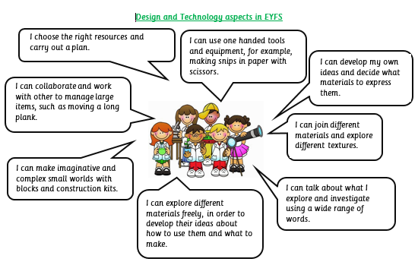

Teaching and learning

The school uses a variety of teaching and learning styles in Design and Technology lessons. The principal aim is to develop children’s knowledge, skills and understanding in Design and Technology. Teachers ensure this through a mixture of whole-class teaching, individual/group activities and access in the classrooms continuous provision.

Within lessons, we give children the opportunity both to work on their own and to collaborate, listening to other children’s ideas and treating these with respect. Children critically evaluate existing products, their own work and that of others.

Planning

Our ‘Progression of Curriculum’ planning allows consistency and development of key vocabulary and skills used with Design and Technology and how this can be applied in other areas of their learning for, example cross curricular links with Art, English, Maths etc. This creates a build-up and continuation of vocabulary right from their entry into School through the EYFS up to their experiences and learning in Year 2.

Through the use of the Development Matters guidance in EYFS and the National Curriculum, there is full coverage of all skills and objectives expected, as well as additional opportunities to recap on these through the year, and into their next class.

Resources

Resources are managed by the DT coordinators, and are restocked and kept up to date based on the planning provided by teachers, and feedback about what needs to be ordered. The resources are also checked termly.

Monitoring and Assessment

The Design and Technology Policy is reviewed in accordance with the rolling programme of policy review. The subject is also monitored through annual data checks, observations (EYFS) termly class project evidence and through work provided in individual learning journals.

Experiences

Early Years Foundation Stage - In the EYFS we provide a rich environment in which we encourage and value creativity. The requirements set out in the Statutory Framework for EYFS encourage practical exploration with a variety of materials, experimenting with colour, design, texture, form and function. Techniques and skills are modelled to children through our use of continuous provision e.g. creative area, investigation area and the construction area.

Design and Technology in KS1 - Our Design and Technology curriculum has been carefully planned as a two year programme of work to ensure coverage (Year 1, Year 2) developing progression throughout school. This has been planned in accordance with the National Curriculum and gives our children the opportunity to:

- Develop skills over time;
- Investigate and evaluate simple products;
- Use a range of materials to design and make simple products;
- Select materials, tools and techniques and explain choices;
- Understand simple mechanisms and structures; and
- Measure, assemble, join and combine materials in a variety of ways using basic tools safely.

