Did you know that your school website can be saved as an icon on tablets and mobile devices? We recommend you show your parents how to do this for quick and easy access. We have put together the following instructions which you may wish to include on your website or in your next newsletter.

How to save the school website as an icon on your iPhone or iPad:
Step 2: Click on the link area to highlight
Step 1: Visit the school website on your mobile device



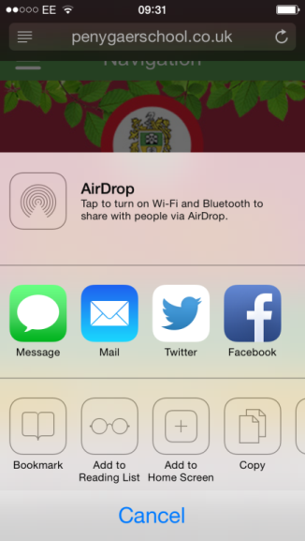
Step 4:
Click Add to home screen
Step 3: Click the save page icon

Step 6: The icon will save to your home screen:
Step 5: Click Add
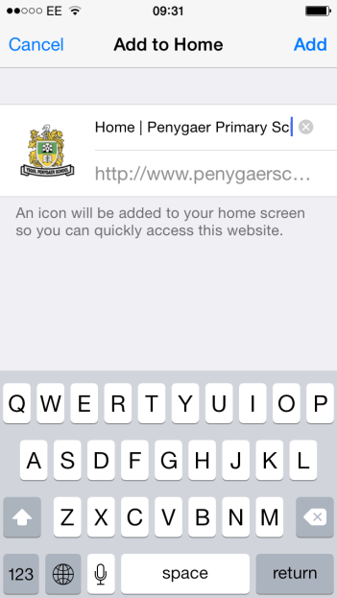
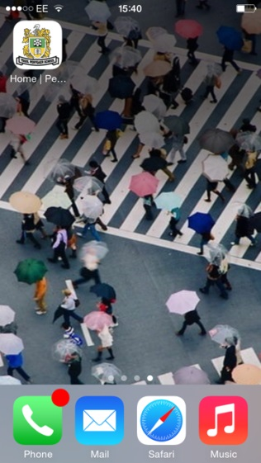

How to save the school website icon to your home screen on a Windows phone:
Step 2: Click to expand options
Step 1: Visit the school website on your mobile device
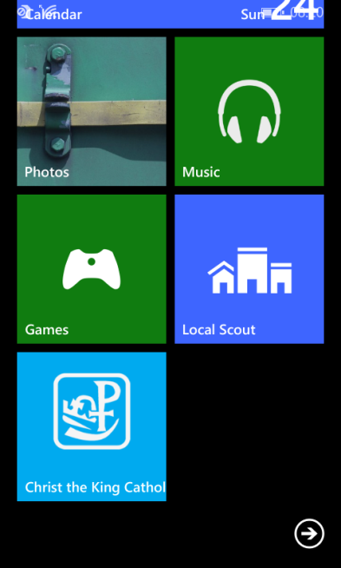
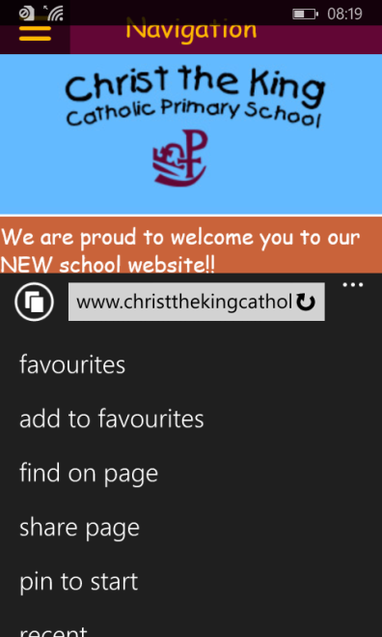

Step 3: Select ‘pin to start’
Step 4: The item will be added to your home screen

How to save the school website icon to your home screen on an Android device:
Step 2: Click to expand options
Step 1: Visit the school website on your mobile device
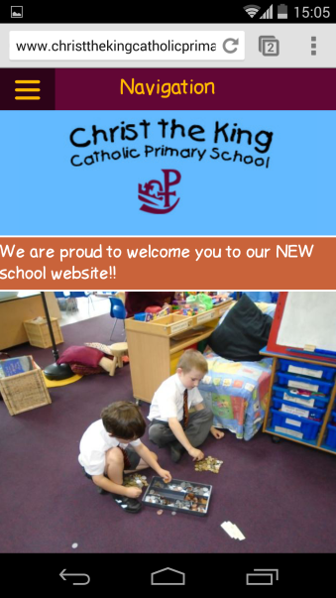
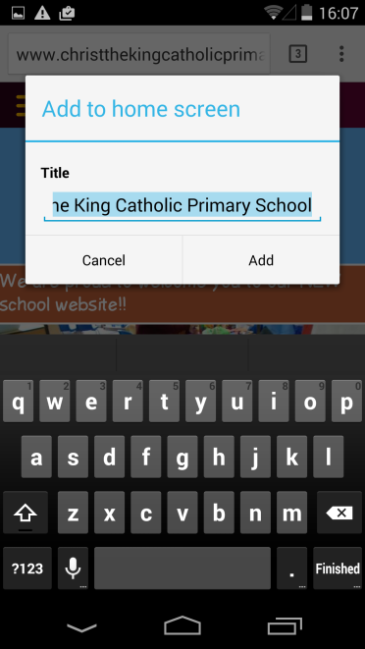
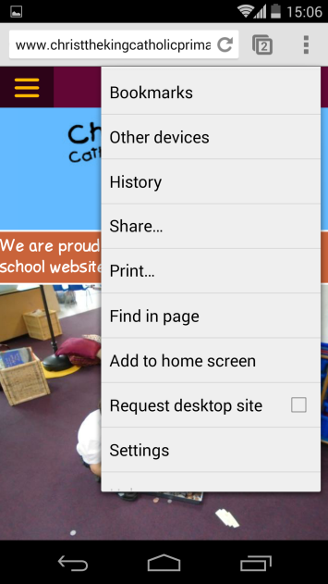
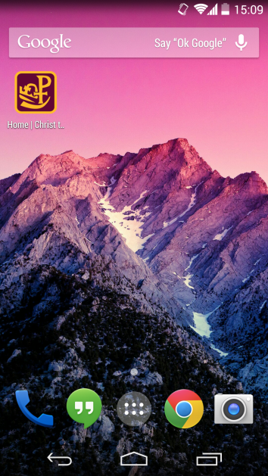
Step 4: Click ‘Add’
Step 3: Select ‘Add to home screen’
Step 5: The item will be added to your home screen

