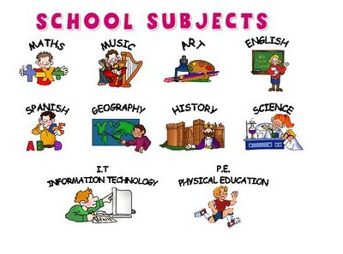  Not now Bernard  “Why is sharing important?”  Flat Stanley  “How can we stay happy and healthy?”  Reading, discussing and voting for our favourite book in the children’s picture book award 2023! | Length and height  Measuring in centimetres and metres, comparing lengths and heights, ordering lengths and heights  Mass, capacity and temperature  Comparing volume and capacity, learning to measure and read scales | Computing  Know how to present information using a computer  Know how to create a pictogram | Investigating with everyday materials Begin to organise things into groups (materials, natural or man-made). Explain the suitability of a variety of everyday materials for particular uses and also explain the physical properties (transparent, opaque, and flexible).
  Know how to cut shape and join fabric to make a simple product. Know how to choose and use appropriate finishing techniques.  Know how to use line and tone. Know how to reflect on the work of an artist. Using different materials for drawing such as pencils, graphite or charcoal. We will understand the different grades of pencils (HB, 2B, 4B) | Year 2– Spring 2  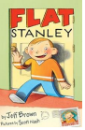  2023  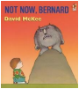 |  |   R.E  Exploring and discussing the story of Easter.  Exploring and discussing what happens during Ramadan.
 |  |  | Learning how to compose and improvise musical conversation with a partner. We will demonstrate an understanding of how the speed of a beat can change, creating a faster or slower pace (tempo).
Sending and receiving  Throwing and catching, rolling, kicking, tracking and stopping a ball.  Target games  Developing skills of throwing, rolling and striking towards targets. | No geography this half term | Recount interesting facts about a Historical event:  Learning about the great fire of London |   Healthy me  Knowing what we need to keep our bodies healthy  Thinking about how to eat healthily and knowing which foods provide the nutrients we need

