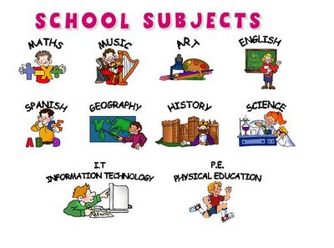  Gorilla by Anthony Browne  Why is nature so amazing?  Poetry  Meerkat mail by Emily Gravett  There’s no place like me…  Letters – persuasive writing | Statistics  Explore making tally charts, block diagrams and pictograms.  Position and direction  Describing movement and turns and language of position. | Using clay  Learning about clay and creating 3D clay tiles with a focus on carving and texture. | Materials  Know how the shapes of solid objects can be changed (squashing, bending, twisting, and stretching).  Know how materials are changed by a heating or cooling process.  Know materials cannot be changed back after being heated, cooled, bent or twisted.
  To complete the water slide challenge. Know how to choose appropriate methods of assembling materials to make a quality product that works (waterproof).  Computing  Making music digitally using 2Sequence. To explore, edit and combine sounds using 2Sequence. | Year 2– Summer 2  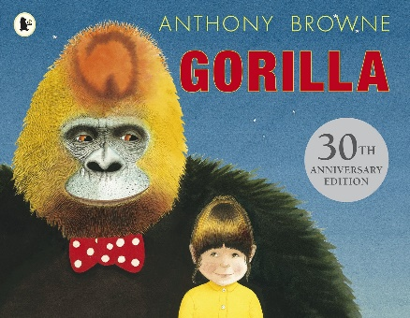  2023  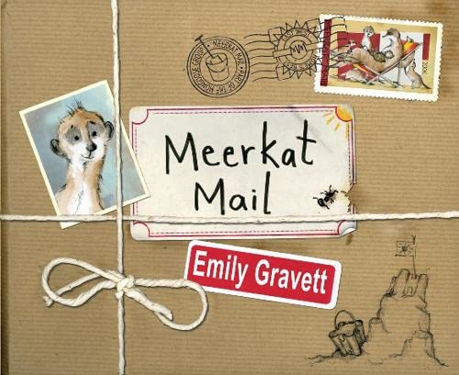 |  |   R.E  Find out about significant journeys and discuss their importance.
 |  |  | Know and understand the graphic symbols of stick notations such as crochet, quavers and crochet rests. Know how to represent chanted rhythm patterns with stick notations.
Athletics  Devlop skills such as running at different speeds, jumping and throwing. Competing to improve their own score and against others. | No Geography this half term | Know how their local area was different in the past. Compare life then to now. |   Changing me  Life cycles, growing from young to old, knowing the difference between boys and girls bodies (using correct names for body parts) and learning that those parts of our bodies are private (staying safe).  Getting ready to transition and move on to the Junior School.

